**Report**

**1)our text file contain**

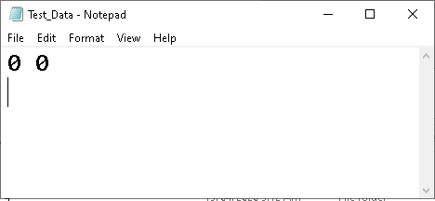

**2) Should click on Start**

**make it on Click to be more easy than console**

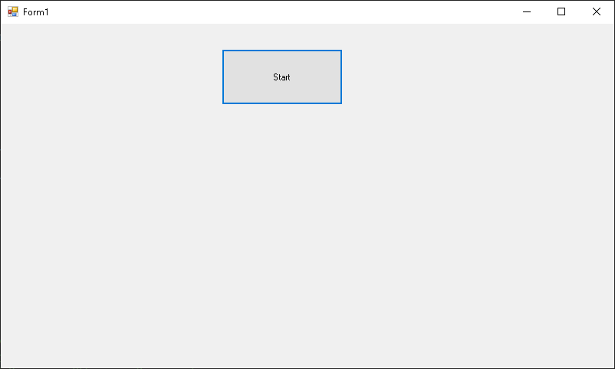

**After click will open the file and read and write**

**2)lets check first run what get**

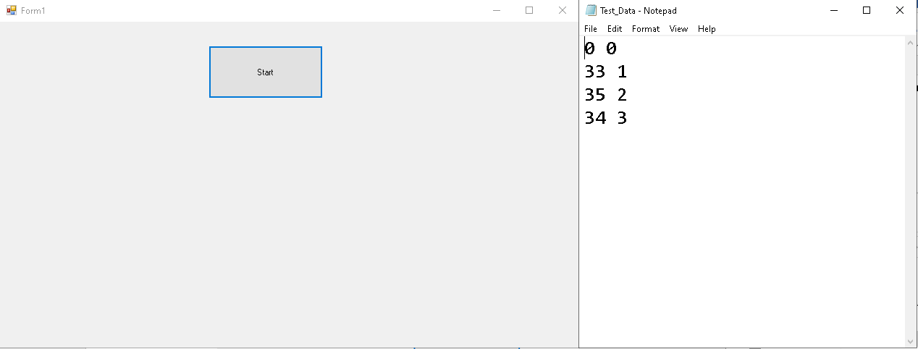

**3)2 run should append and take the incremented second number**

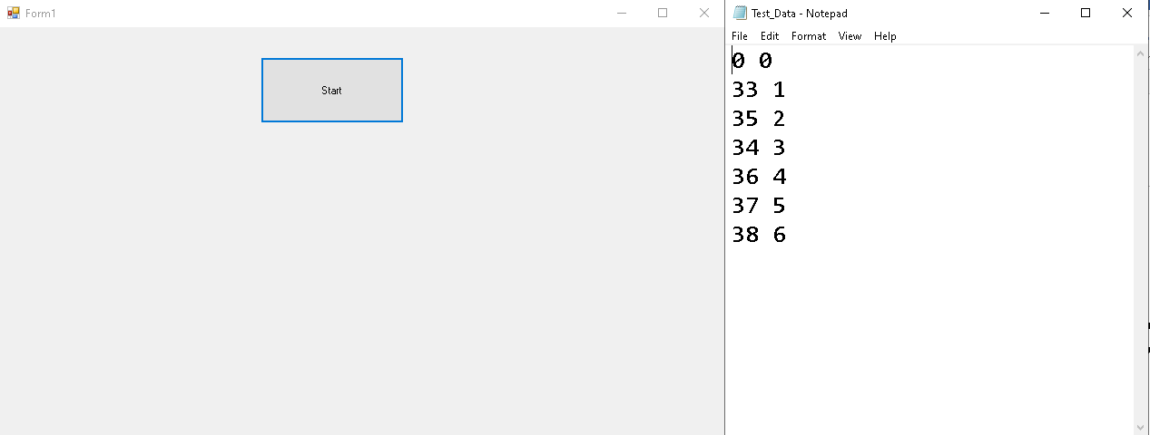

**4) here in debug we can see the thread inside function do his work**

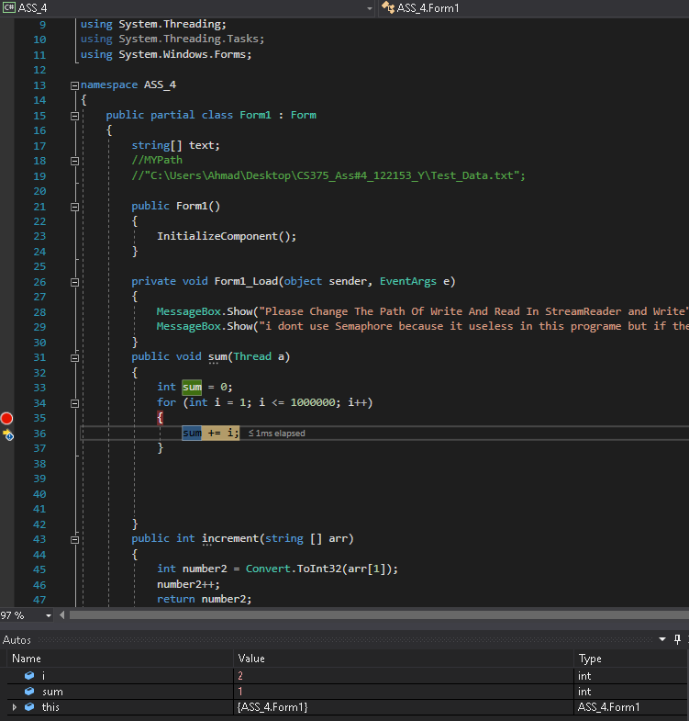

**Note:**

**\***

**I make The Path static You can change it in stream reader and write any place**

**\* \***

**don’t use Thread.sleep();**

**Because useless with my solution but if There point on this can but it on any function Thread.sleep(1000)**

**And I put it after modify**